**INTERNATIONAL CREATIVITY AND INNOVATION DAY**

**AI – ASSISTANT(INRODUCTION):**

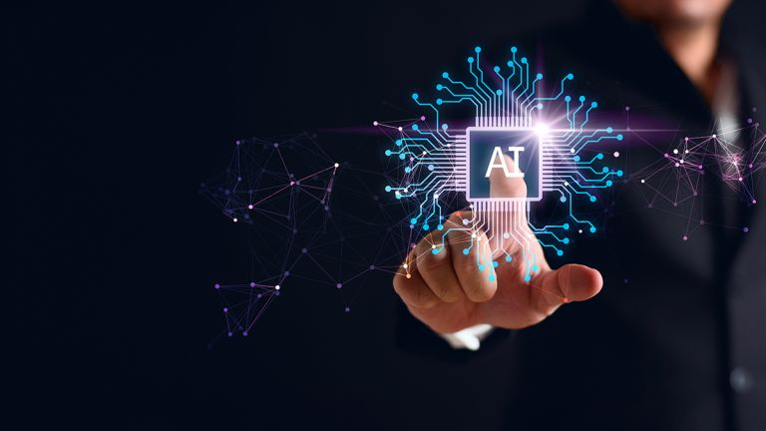Artificial intelligence (AI) is a broad field of computer science that focuses on creating machines capable of performing tasks that typically require human intelligence. It involves developing algorithms and models that can learn, reason, and make decisions, similar to how humans do.

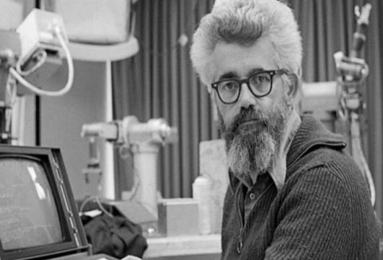**FOUNDER AND INNOVATOR** (INTRODUCTION):

Contributions in computer science. **John McCarthy**is one of the "founding fathers" of artificial intelligence, together with Alan Turing, Marvin Minsky, Allen Newell, and Herbert A. Simon. McCarthy, Minsky, Nathaniel Rochester and Claude E.

John MC Carthy

* **AI has been used to solve a wide range of real-world problems across many industries:**

**1. Healthcare**

**Problem Solved:** Delayed diagnosis and medical errors  
**AI Solution:** AI systems like IBM Watson and Google’s DeepMind assist doctors in diagnosing diseases (e.g., cancer, diabetic retinopathy) faster and more accurately by analyzing medical images and patient data.

**2. Transportation**

**Problem Solved**: Traffic congestion and accidents  
**AI Solution**: AI powers self-driving car systems (e.g., Tesla Autopilot) and smart traffic management, helping reduce accidents and improve traffic flow using real-time data.

**3. Agriculture**

**Problem Solved**: Crop diseases and inefficient farming  
**AI Solution**: AI drones and image recognition help detect plant diseases early, monitor crop health, and optimize irrigation, increasing yields and reducing waste.

* **Founders' Thought Process Behind AI:**

1. **Mimicking Human Intelligence:**

They believed that if human intelligence could be broken down into clear steps and rules, then a machine could be programmed to simulate that thinking

1. **Logic and Problem Solving:**

They focused on replicating logical reasoning—how humans solve puzzles or play chess—using symbolic systems. Early AI was all about creating machines that could follow logical rules and solve problems step-by-step**.**

1. **Making Machines Learn:**

Even in the early stages, they hoped machines could improve over time—essentially, learn from data. This led to early experiments in machine learning, even though computing power was limited.

* **AI founders started, broken down into plan, tools, and research** —

**1. PLAN**

* **Dartmouth Conference (1956):** Official start of AI; proposed by John McCarthy and others.
* **Main goal:** Build machines that can simulate human intelligence (learning, reasoning, understanding language).
* **Assumption:** Human intelligence could be formalized and recreated in a machine.

**2. TOOLS**

* **Mathematical Logic:** Used to model reasoning and problem-solving.
* **LISP Programming Language:** Created by John McCarthy in 1958, became the main AI language.
* **Symbolic Systems:** Programs that used rules and symbols to mimic reasoning.
* **Simple Computers:** Like IBM 701 — low processing power, but used for early experiments.
* **Algorithms:** Search algorithms, rule-based systems, and early decision-making models.

**3.RESEARCH**

* **Problem Solving:** Logic Theorist (1955) solved math theorems like a human.
* **Game Playing:** Programs that played checkers and chess to demonstrate machine intelligence.
* **Natural Language Processing:** Early machine translation projects (e.g., English to Russian).
* **Learning Systems:** Perceptron (1958) — early model of neural networks for pattern recognition.
* **Cognitive Modeling:** Mimicking how humans think and solve problems.
* **Make Their Solution Creative:**

**1. Thinking Beyond Physical Machines**

* Before AI, computers were seen only as number-crunching tools.
* The founders imagined computers **thinking**, **learning**, and **reasoning** — a radical idea at the time.

**2. Using Human Logic in Code**

* They creatively used **logic and symbols** (not just math) to model how humans solve problems.
* For example, the **Logic Theorist** program mimicked how mathematicians prove theorems.

**3. Designing Machines That Learn**

* The **Perceptron** introduced the idea that machines could learn from examples, similar to how the brain works.
* This planted the seed for **machine learning** and **neural networks**, key to modern AI.
* **What Surprised AI the Most:**

How much **progress** has matched (and sometimes exceeded) their early dreams.

* What started as programs playing checkers or solving logic puzzles...
* ...has become AI writing poetry, diagnosing diseases, driving cars, and holding conversations.

The **scale and speed** of progress — especially with **machine learning** and **neural networks** — was surprising. Many early founders thought general AI might take a century or more. Yet today, we’re already seeing systems (like GPT-4) that handle language, reasoning, and learning in ways they only hoped for.

* **AI – What Did We Learn About Innovation:**

**🔹 1. Big Ideas Start Small**

* AI began with basic programs solving puzzles and playing games.
* Even simple breakthroughs can lay the foundation for major revolutions.

**🔹 2. Imagination Drives Innovation**

* The AI pioneers imagined machines that could think — long before it was technically possible.
* Vision fuels invention.

**🔹 3. Interdisciplinary Thinking Matters**

* AI combined **math, computer science, psychology, linguistics**, and more.
* Innovation often comes from blending ideas across fields.

**🔹 4. New Tools Create New Possibilities**

* John McCarthy created **LISP** to build AI — a programming language built for intelligence.
* Innovation often requires building **custom tools**.

**🔹 5. Failure Is Part of the Process**

* Many early AI models (like the Perceptron) hit limitations and were dismissed — only to return stronger decades later.
* Setbacks often lead to deeper understanding.
* **AI-What Surprised Me About How Simple Ideas Became Big Tech:**

**1. Tiny Experiments Led to Massive Impact**

* Early AI programs just solved puzzles or played checkers.
* Today, the same core concepts power **chatbots, self-driving cars, and medical diagnostics**.

**2. Basic “If-Then” Logic Turned Into Smart Decision-Making**

* Simple rule-based systems evolved into complex AI that makes real-time decisions in finance, healthcare, and logistics.

**3. A Simple Learning Model (Perceptron) Became the Basis for Deep Learning**

* The 1958 Perceptron was a basic neural network.
* Now it’s the foundation of deep learning — behind **Google Translate, facial recognition, and ChatGPT**.

**4. Language Rules Became Conversational AI**

* Early AI just translated words with grammar rules.
* Now, AI can understand and **hold full conversations**, even generate stories and explain ideas.

**5. Academic Curiosity Became Everyday Tech**

* What began as university experiments are now part of daily life — **smart assistants, recommendations, auto-correct, and more**.
* **Impact of AI Innovation on People’s Lives:**

**1. Improved Healthcare**

* Faster and more accurate diagnoses (e.g., cancer detection).
* Personalized treatment plans.
* AI-powered robots assist in surgeries.

**2. Better Communication**

* Real-time translation breaks language barriers.
* Virtual assistants (like Siri, Alexa) help with daily tasks.
* AI chatbots provide instant customer support.

**3. Enhanced Convenience**

* Smart homes automate lighting, heating, and security.
* Personalized recommendations in shopping, music, and entertainment.
* Self-driving cars promise safer and more efficient travel.

**4. Education Access and Personalization**

* Adaptive learning platforms tailor lessons to students’ needs.
* Online tutoring powered by AI helps learners anywhere.
* Language learning apps use AI for better practice and feedback.

**5. Job Transformation**

* Automation of repetitive tasks frees people for creative work.
* New jobs in AI development, data science, and ethics.

.

**Conclusion**

Artificial Intelligence began as a bold idea to replicate human intelligence in machines. What started with simple programs solving puzzles has grown into a powerful technology transforming nearly every aspect of our lives. Through creativity, interdisciplinary research, and relentless curiosity, AI pioneers laid the groundwork for systems that now help doctors save lives, improve communication, and automate daily tasks.

The journey of AI teaches us that **big innovations often come from simple ideas combined with vision and persistence**. While AI brings incredible benefits, it also challenges us to use it responsibly and thoughtfully, ensuring it improves life for everyone.

The future of AI holds even greater promise—continually pushing the boundaries of what machines and humans can achieve together.